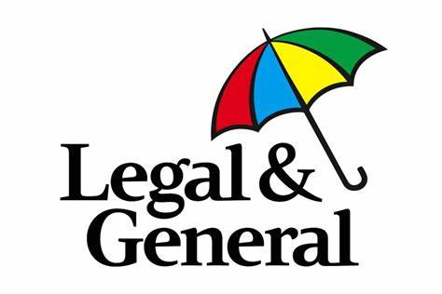

Do you thrive in sharing knowledge through mentoring? Are you technically minded, with a background in insurance or financial services? Are you passionate about supporting a business in achieving its engagement, quality and compliance goals? If so, this may be the role for you!
We are looking to hire a Training and Technical Audit Consultant to join us on a hybrid basis where you’ll be part office (Hove) and part home-based. Base salary up to £40,000 depending on experience. We are not strictly looking for someone with this exact experience but, someone with the natural strengths and potential to thrive in this role following a supportive and in-depth induction.
This is a multi-faceted role meaning no two days will be the same! You’ll be providing training, leading technical appeals and audit services for our Claims and Group Protection business areas. Through collaborative engagement and understanding of the needs of the business, you’ll be driving of continuous change and improvement.
What you'll be doing:
- Supporting the development, design and delivery of comprehensive training programmes for new starters.
- Ensuring that the quality and competency of staff is maintained across claims and other areas of Group Protection.
- Leading the Technical and Governance Team in the delivery of legislative, regulatory or process change training.
- Conducting and delivering monthly audits.
- Defining, developing and delivering continuous processes and systems improvements, to ensure that all our teams always deliver first customer service.
- Utilising analysed statistical data and case studies to provide the business area with relevant findings regarding trends from claims activity, audits, complaints and appeals.
- Contributing to company and Group Protection wide projects and process reviews to deliver product, customer experience and system improvements.
- Develop, define and deliver processes and systems to ensure that all customer data is dealt with in a compliant manner.
Who we're looking for:
- Someone who loves sharing knowledge with others, someone with natural coaching ability with strong communication skills.
- Someone with a financial services background who can develop and ultimately thrive in this role.
- Proven analytical and risk management skills with strong attention to detail.
- Proven ability to design and deliver training and development programmes.
- Ability to represent the department at internal/external meetings.
- Effective organisational skills with the ability to work to targets and deadlines.
Benefits:
Whatever your role, we reward ability, performance and attitude with a package that looks after all the things that are important to you. Our employees have a wide range of benefits including a generous pension scheme, life assurance, 25 days’ holiday, private medical insurance, discretionary performance related bonuses, paid overtime, a variety of share schemes, discounts at both a huge range of high street stores and our own great products. Your hard work will be rewarded when you join us.
If this sounds like you then we would love to hear from you! Please apply here: Legal & General: Claims Training & Technical Audit Consultant (legalandgeneralgroup.com) OR contact laura.hale@landg.com for more information.

